

**A Report on Software Development Project II**

**Course Title** : Software Development Project II. **Course No**. : CSE 3200

**Submitted by Submitted to**

**Name**: Md. Shabir Khan Akash. Dr. Boshir Ahmed

**Class**: 3rd year, Even semester. Professor

**Department** : CSE Department of CSE, RUET

**Roll**: 1603108

**Section:** B

**Contact No**: 01794598178

**E-mail**: 4175.akash@gmail.com

**Name of the Project** : Developing a simple photo editor using Python programming language.

**Used Language** : Python

**Used Framework/Module**: tkinter, PIL, time packages and modules of Python library etc.

**Project Platform**: Desktop Application for Windows platform.

**Main User Interface and Functionalities**:

**1) Crop Segment**: After opening an image by clicking on the top right box icon, then In this crop segment, the image can be cropped. For this, user needs to enter the value of (X1,Y1) and (X2,Y2)

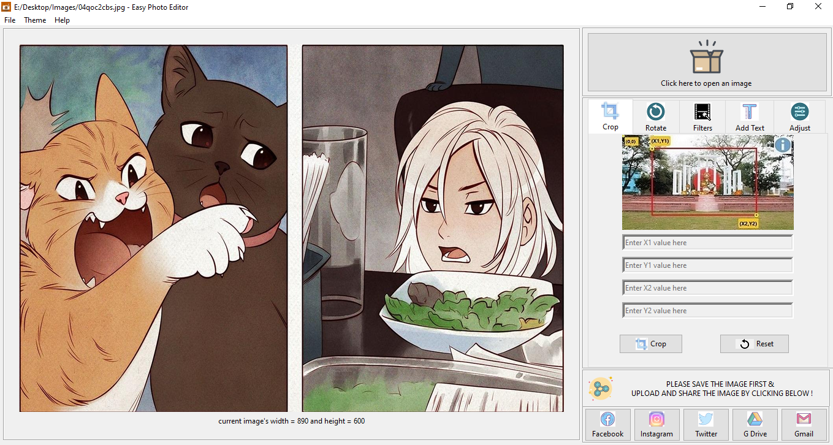

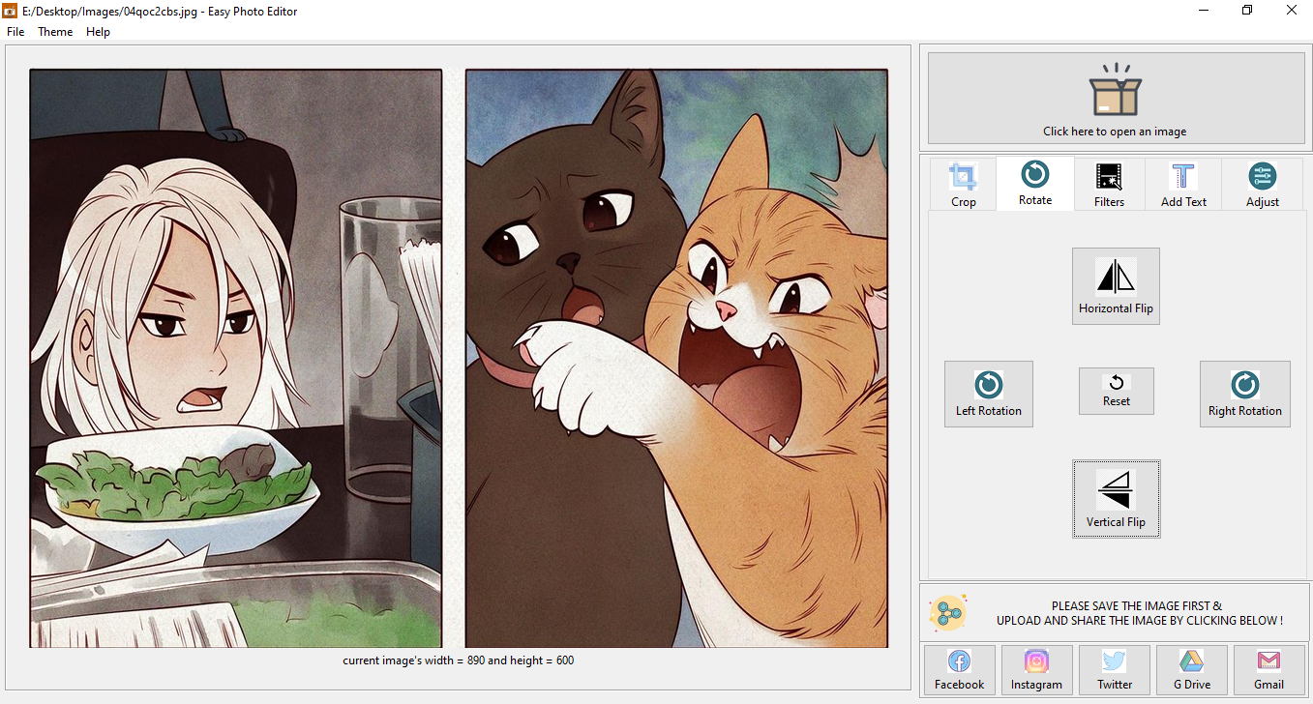**2) Rotate Segment**: Clicking on the “**Rotate**” tab, user can rotate the image 90o left and right by clicking on the “Rotate Left” and “Rotate Right” respectively. Then there are two buttons named “Horizontal Flip” and “Vertical Flip” to flip the image horizontally and vertically respectively.

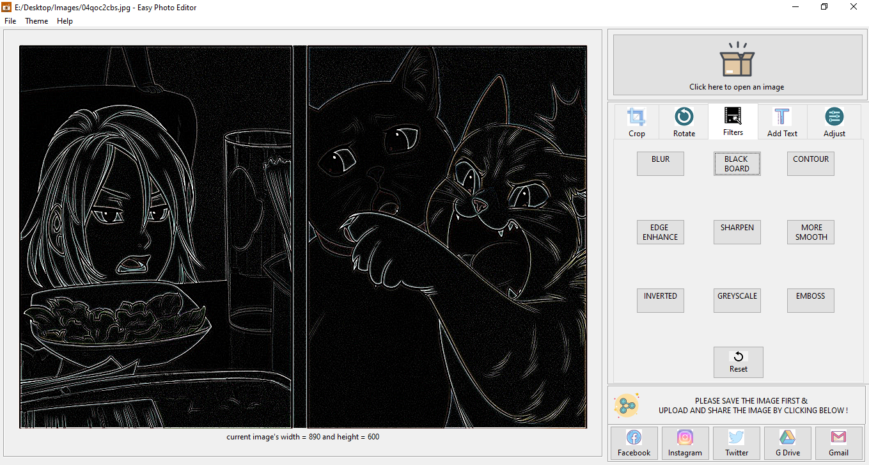**3) Filters Segment:** Clicking on the “**Filters**” tab, user can add some filters effects on their image. There is some buttons for each of the filter effects. By clicking on the button, corresponding filter will be applied on the image.

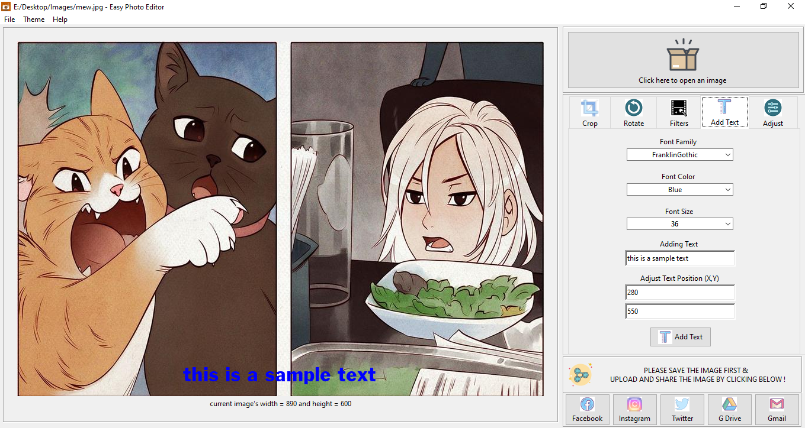**4) Text Segment**: Clicking on the “**Add Text**” tab, user can add text on the images, to add text, user has to select a font family, font color, font size, the main text and the co-ordinates or the position of the text. Finally clicking on the “Add Text” button, text will be added to the image.

**5) Adjust Segment:** Clicking on the “**Adjust**” tab, user can adjust brightness, contrast, shadow, saturation, sharpness, enhancement by tuning the scroller and click the apply icon to apply the changes.

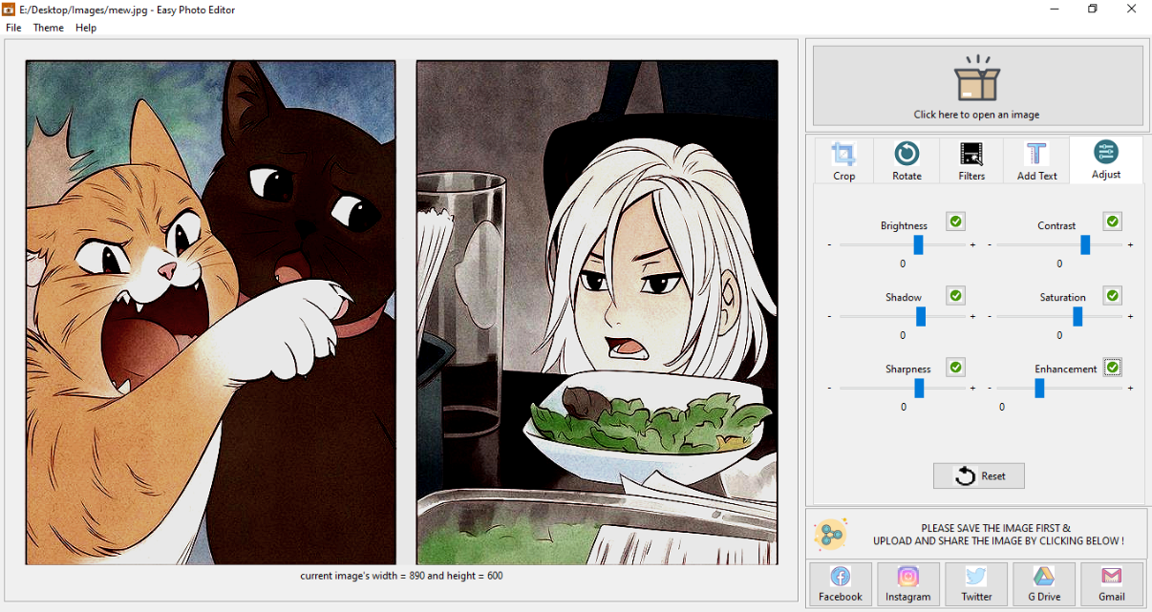

**6) Share Segment and others**: By clicking on the bottom right corner’s icons, user will be redirected to the corresponding social websites such as Facebook, twitter, Instagram, google drive, Gmail and user will be able to share his/her images. And there is a “**Reset**” button in all the tabs in the editing tools section, using that button will reset the image to its original form. Also on the top left Menu-bar, in the file section user can open image, save, rename and quit the application. In the Theme section of menu-bar, user can choose a theme between Light default, Light Plus, Dark, Monokai, Red, Night Blue. Finally in the Help section, user can check for updates, learn about the app and report bugs to dev’s mail.